1. Create a VM and install docker and test the images inside the container with the commands

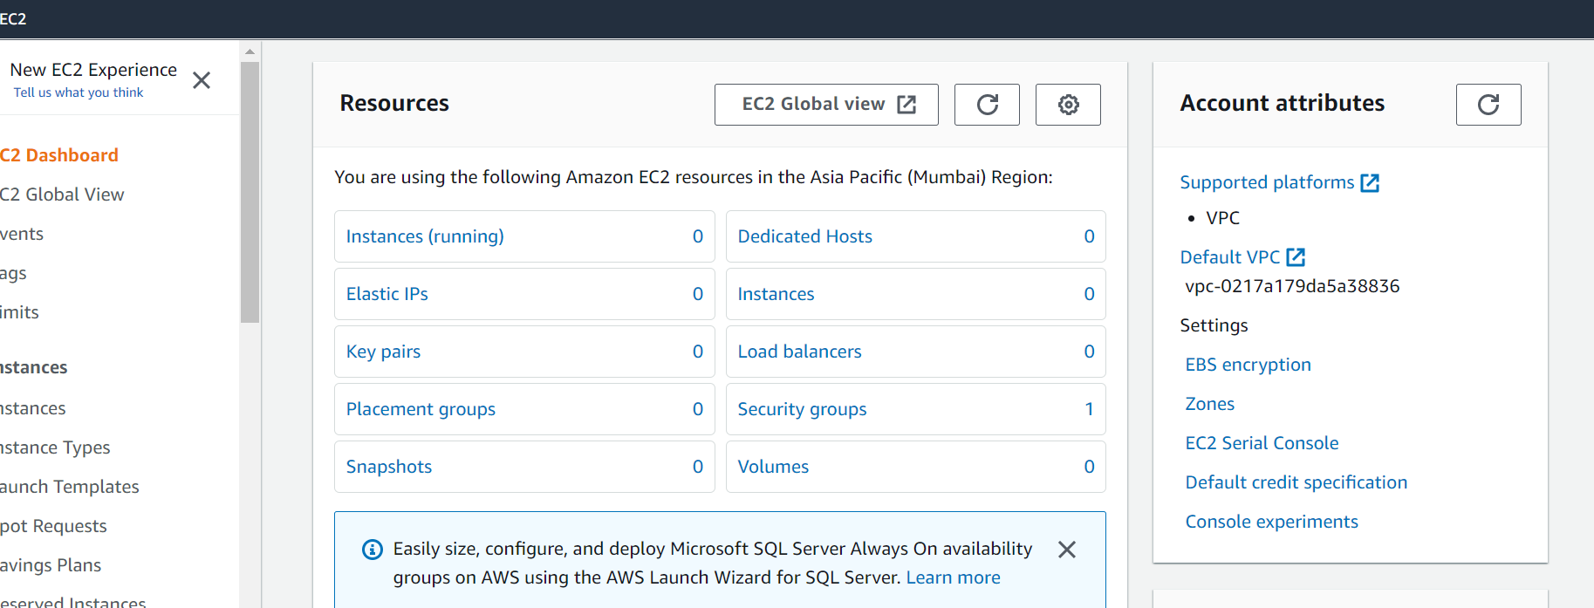

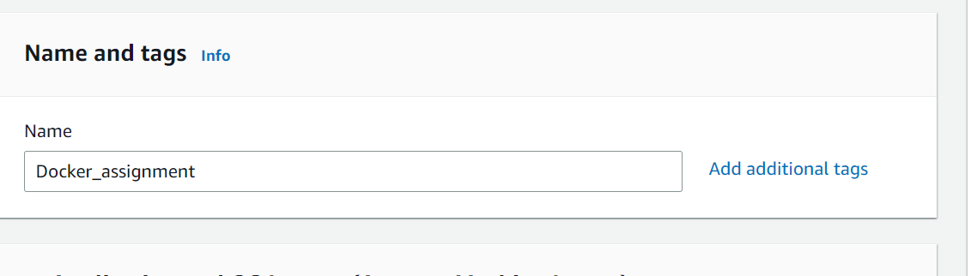

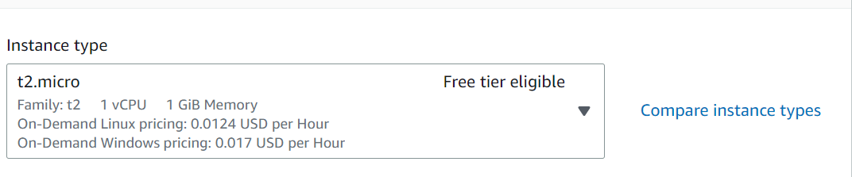

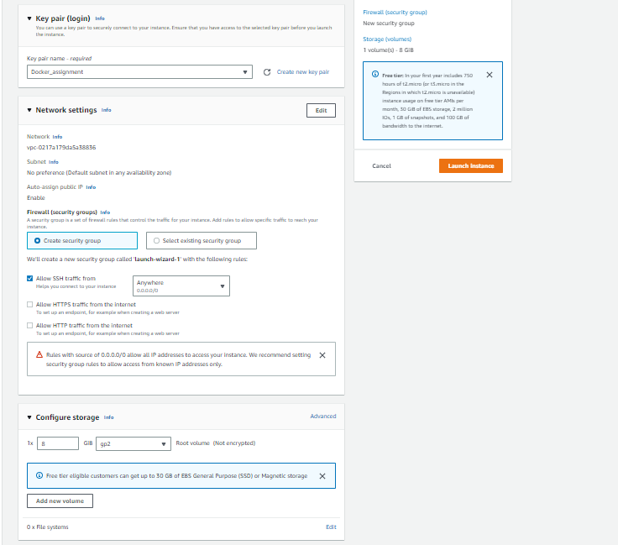

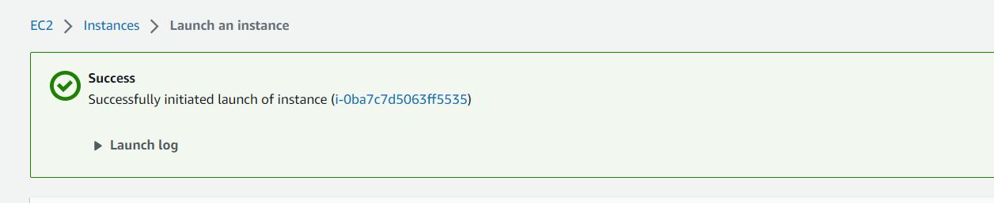

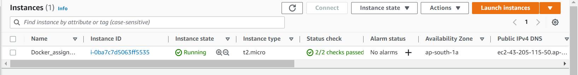

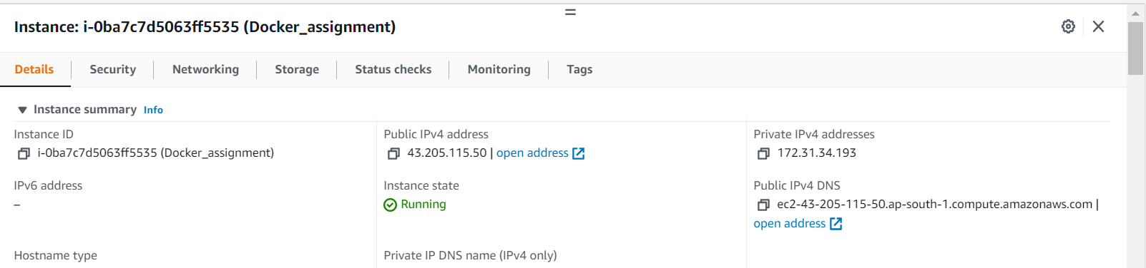

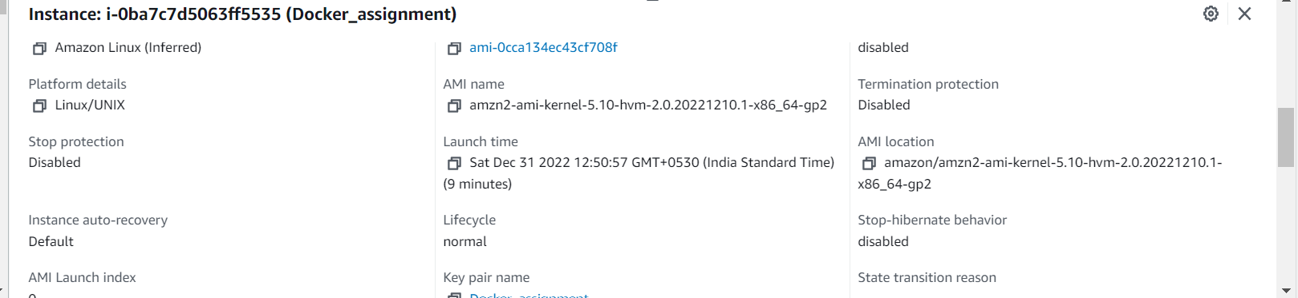

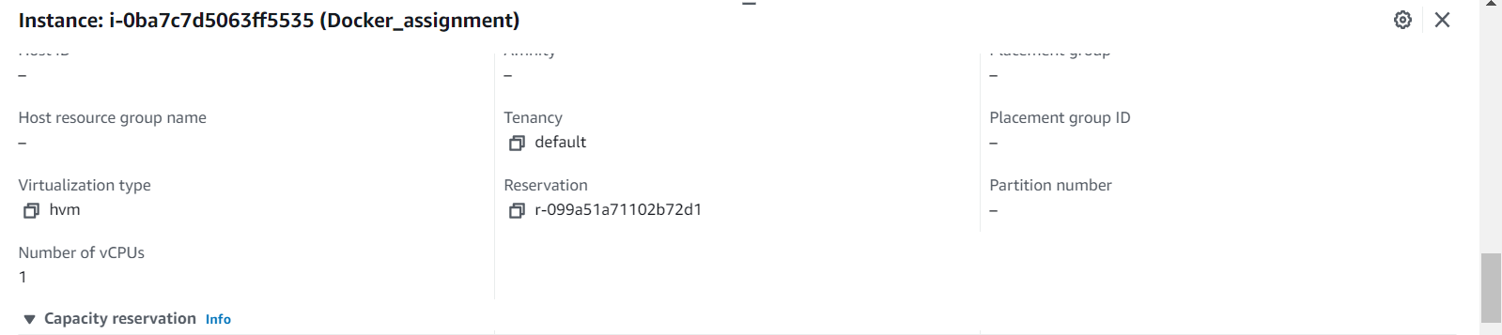

[ec2-user@ip-172-31-34-193 ~]$ sudo yum install httpd

Loaded plugins: extras_suggestions, langpacks, priorities, update-motd

Resolving Dependencies

--> Running transaction check

---> Package httpd.x86_64 0:2.4.54-1.amzn2 will be installed

--> Processing Dependency: httpd-tools = 2.4.54-1.amzn2 for package: httpd-2.4.54-1.amzn2.x86_64

--> Processing Dependency: httpd-filesystem = 2.4.54-1.amzn2 for package: httpd-2.4.54-1.amzn2.x86_64

--> Processing Dependency: system-logos-httpd for package: httpd-2.4.54-1.amzn2.x86_64

--> Processing Dependency: mod_http2 for package: httpd-2.4.54-1.amzn2.x86_64

--> Processing Dependency: httpd-filesystem for package: httpd-2.4.54-1.amzn2.x86_64

--> Processing Dependency: /etc/mime.types for package: httpd-2.4.54-1.amzn2.x86_64

--> Processing Dependency: libaprutil-1.so.0()(64bit) for package: httpd-2.4.54-1.amzn2.x86_64

--> Processing Dependency: libapr-1.so.0()(64bit) for package: httpd-2.4.54-1.amzn2.x86_64

--> Running transaction check

---> Package apr.x86_64 0:1.7.0-9.amzn2 will be installed

---> Package apr-util.x86_64 0:1.6.1-5.amzn2.0.2 will be installed

--> Processing Dependency: apr-util-bdb(x86-64) = 1.6.1-5.amzn2.0.2 for package: apr-util-1.6.1-5.amzn2.0.2.x86_64

---> Package generic-logos-httpd.noarch 0:18.0.0-4.amzn2 will be installed

---> Package httpd-filesystem.noarch 0:2.4.54-1.amzn2 will be installed

---> Package httpd-tools.x86_64 0:2.4.54-1.amzn2 will be installed

---> Package mailcap.noarch 0:2.1.41-2.amzn2 will be installed

---> Package mod_http2.x86_64 0:1.15.19-1.amzn2.0.1 will be installed

--> Running transaction check

---> Package apr-util-bdb.x86_64 0:1.6.1-5.amzn2.0.2 will be installed

--> Finished Dependency Resolution

Dependencies Resolved

=============================================================================================================================================================================================

Package Arch Version Repository Size

=============================================================================================================================================================================================

Installing:

httpd x86_64 2.4.54-1.amzn2 amzn2-core 1.4 M

Installing for dependencies:

apr x86_64 1.7.0-9.amzn2 amzn2-core 122 k

apr-util x86_64 1.6.1-5.amzn2.0.2 amzn2-core 99 k

apr-util-bdb x86_64 1.6.1-5.amzn2.0.2 amzn2-core 19 k

generic-logos-httpd noarch 18.0.0-4.amzn2 amzn2-core 19 k

httpd-filesystem noarch 2.4.54-1.amzn2 amzn2-core 24 k

httpd-tools x86_64 2.4.54-1.amzn2 amzn2-core 88 k

mailcap noarch 2.1.41-2.amzn2 amzn2-core 31 k

mod_http2 x86_64 1.15.19-1.amzn2.0.1 amzn2-core 149 k

Transaction Summary

=============================================================================================================================================================================================

Install 1 Package (+8 Dependent packages)

Total download size: 1.9 M

Installed size: 5.2 M

Total download size: 1.9 M

Installed size: 5.2 M

Is this ok [y/d/N]: y

Downloading packages:

(1/9): apr-1.7.0-9.amzn2.x86_64.rpm | 122 kB 00:00:00

(2/9): apr-util-1.6.1-5.amzn2.0.2.x86_64.rpm | 99 kB 00:00:00

(3/9): apr-util-bdb-1.6.1-5.amzn2.0.2.x86_64.rpm | 19 kB 00:00:00

(4/9): generic-logos-httpd-18.0.0-4.amzn2.noarch.rpm | 19 kB 00:00:00

(5/9): httpd-filesystem-2.4.54-1.amzn2.noarch.rpm | 24 kB 00:00:00

(6/9): httpd-2.4.54-1.amzn2.x86_64.rpm | 1.4 MB 00:00:00

(7/9): httpd-tools-2.4.54-1.amzn2.x86_64.rpm | 88 kB 00:00:00

(8/9): mailcap-2.1.41-2.amzn2.noarch.rpm | 31 kB 00:00:00

(9/9): mod_http2-1.15.19-1.amzn2.0.1.x86_64.rpm | 149 kB 00:00:00

---------------------------------------------------------------------------------------------------------------------------------------------------------------------------------------------

Total 9.8 MB/s | 1.9 MB 00:00:00

Running transaction check

Running transaction test

Transaction test succeeded

Running transaction

Installing : apr-1.7.0-9.amzn2.x86_64 1/9

Installing : apr-util-bdb-1.6.1-5.amzn2.0.2.x86_64 2/9

Installing : apr-util-1.6.1-5.amzn2.0.2.x86_64 3/9

Installing : httpd-tools-2.4.54-1.amzn2.x86_64 4/9

Installing : httpd-filesystem-2.4.54-1.amzn2.noarch 5/9

Installing : generic-logos-httpd-18.0.0-4.amzn2.noarch 6/9

Installing : mailcap-2.1.41-2.amzn2.noarch 7/9

Installing : mod_http2-1.15.19-1.amzn2.0.1.x86_64 8/9

Installing : httpd-2.4.54-1.amzn2.x86_64 9/9

Verifying : apr-util-1.6.1-5.amzn2.0.2.x86_64 1/9

Verifying : apr-util-bdb-1.6.1-5.amzn2.0.2.x86_64 2/9

Verifying : httpd-tools-2.4.54-1.amzn2.x86_64 3/9

Verifying : mod_http2-1.15.19-1.amzn2.0.1.x86_64 4/9

Verifying : httpd-2.4.54-1.amzn2.x86_64 5/9

Verifying : mailcap-2.1.41-2.amzn2.noarch 6/9

Verifying : generic-logos-httpd-18.0.0-4.amzn2.noarch 7/9

Verifying : httpd-filesystem-2.4.54-1.amzn2.noarch 8/9

Verifying : apr-1.7.0-9.amzn2.x86_64 9/9

Installed:

httpd.x86_64 0:2.4.54-1.amzn2

Dependency Installed:

apr.x86_64 0:1.7.0-9.amzn2 apr-util.x86_64 0:1.6.1-5.amzn2.0.2 apr-util-bdb.x86_64 0:1.6.1-5.amzn2.0.2 generic-logos-httpd.noarch 0:18.0.0-4.amzn2

httpd-filesystem.noarch 0:2.4.54-1.amzn2 httpd-tools.x86_64 0:2.4.54-1.amzn2 mailcap.noarch 0:2.1.41-2.amzn2 mod_http2.x86_64 0:1.15.19-1.amzn2.0.1

Complete!

[ec2-user@ip-172-31-34-193 ~]$ sudo amazon-linux-extras install docker

Installing docker

Loaded plugins: extras_suggestions, langpacks, priorities, update-motd

Cleaning repos: amzn2-core amzn2extra-docker amzn2extra-kernel-5.10

17 metadata files removed

6 sqlite files removed

0 metadata files removed

Loaded plugins: extras_suggestions, langpacks, priorities, update-motd

amzn2-core | 3.7 kB 00:00:00

amzn2extra-docker | 3.0 kB 00:00:00

amzn2extra-kernel-5.10 | 3.0 kB 00:00:00

(1/7): amzn2-core/2/x86_64/group_gz | 2.5 kB 00:00:00

(2/7): amzn2-core/2/x86_64/updateinfo | 539 kB 00:00:00

(3/7): amzn2extra-docker/2/x86_64/updateinfo | 8.0 kB 00:00:00

(4/7): amzn2extra-docker/2/x86_64/primary_db | 99 kB 00:00:00

(5/7): amzn2extra-kernel-5.10/2/x86_64/updateinfo | 22 kB 00:00:00

(6/7): amzn2extra-kernel-5.10/2/x86_64/primary_db | 14 MB 00:00:00

(7/7): amzn2-core/2/x86_64/primary_db | 68 MB 00:00:01

Resolving Dependencies

--> Running transaction check

---> Package docker.x86_64 0:20.10.17-1.amzn2.0.1 will be installed

--> Processing Dependency: runc >= 1.0.0 for package: docker-20.10.17-1.amzn2.0.1.x86_64

--> Processing Dependency: libcgroup >= 0.40.rc1-5.15 for package: docker-20.10.17-1.amzn2.0.1.x86_64

--> Processing Dependency: containerd >= 1.3.2 for package: docker-20.10.17-1.amzn2.0.1.x86_64

--> Processing Dependency: pigz for package: docker-20.10.17-1.amzn2.0.1.x86_64

--> Running transaction check

---> Package containerd.x86_64 0:1.6.8-1.amzn2 will be installed

---> Package libcgroup.x86_64 0:0.41-21.amzn2 will be installed

---> Package pigz.x86_64 0:2.3.4-1.amzn2.0.1 will be installed

---> Package runc.x86_64 0:1.1.4-1.amzn2 will be installed

--> Finished Dependency Resolution

Dependencies Resolved

=============================================================================================================================================================================================

Package Arch Version Repository Size

=============================================================================================================================================================================================

Installing:

docker x86_64 20.10.17-1.amzn2.0.1 amzn2extra-docker 39 M

Installing for dependencies:

containerd x86_64 1.6.8-1.amzn2 amzn2extra-docker 27 M

libcgroup x86_64 0.41-21.amzn2 amzn2-core 66 k

pigz x86_64 2.3.4-1.amzn2.0.1 amzn2-core 81 k

runc x86_64 1.1.4-1.amzn2 amzn2extra-docker 2.9 M

Transaction Summary

=============================================================================================================================================================================================

Install 1 Package (+4 Dependent packages)

